MUBTASIM FUAD

Daffodil International University, Dhaka, Bangladesh

@ mubtasim.fuad.cs@gmail.com

+8801316100360

in linkedin.com/in/mubtasim-fuad-960788246

github.com/mubtasim47

EMPLOYMENT

Lab Associate

Department of CSE, DIU

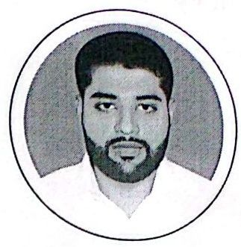

EDUCATION

B.Sc. in Computer Science and Engineering

October 2022-Present

Daffodil Smart City, Savar, Dhal

Daffodil International University

Assigned in the courses including Problem Solving, Data Structu e, OOP,and Artficial Intelligence Lab.

Assist students during their lab activities/coding tasks.

Keep faculty informed about the progress of the students in the lab.

Monitor student activities at the time oflab performance/examination.

CAREER OBJECTIVE

Seeking a position as a software engineer in an IT firm. I may no be the best fit for the company, but I believe I am capable oflearnin any new technology if I am provided with the right opportunities. In the long run, I could be a valuable asset to the company that hired me.



Prediction of Chronic Kidney Disease

github.com/Mubtasim47/ckd-prediction

July 2022-September 2022

·A project using machine learning to determine if a person has cl ronic kidney disease or not.

·The chronic kidney disease dataset from the UCI repository was used to train the model using ten different ML techniques.

· Different analytics, such as Accuracy Score, Jaccard Similarity In iex,. Cross Validated Score, and ROC-AUC score, are used to measur performance of the model.

Record Keeping Android Application

github.com/Mubtasim47/Simple-Record-Keeping-App

March 2022-April 2022

·A very simple record keeping android app where the data of a student can be stored into firebase.

·User authentication is provided by the firebase authentication database and all other information are kept into a realtime data ase.

A Village Scenario Drawing using OpenGL C++

github.com/Mubtasim47/village_scenario

March 2022-April 2022

·All shapes have been drawn with the help of different OpenGL.s ape functions.

Passing Year:2022 CGPA:3.94

Higher Secondary Certificate

Joypurhat Government College

Passing Year:2016 GPA:5.00

Secondary School Certificate

R.B.Government High School

Passing Year : 2014 GPA:5.00

PERSONAL SKILLS

Programming Language.

Idea about commonly used Data Structures such as Linked List,Stack, Queue,Binary Trees,and Graph.

Understanding of OOP concepts using core Java (Software:Eclipse,Netbeans, IntelliJ IDEA).

Have knowledge in building a website with HTML,CSS,Bootstrap,JS and PHP.

Completed a research-based project using different Data Mining and ML Techniques (Software Used: Jupyter Notebook, Google Colab,Heroku CLI).

Have basic knowledge about Git commands and familiar with working with Git Command Line Interface (Git Bash).

Familiar with using some of the Google Workspace Apps like Gocgle-Sheets, Google Docs,Google Classroom and Google Sites.

PERTICIPATION

·Participated in the DIU Take-Off Programming Contest (41st among 300 students).

·Solved nearly 150 programming problems on different online judges like URI, LightOJ and Codeforces.

Attended a Six Hour Training on "A Basic IntroductiontorintdCircuit Roard